1. **场馆场地个数：**

|  |  |  |  |
| --- | --- | --- | --- |
|  | 篮球 | 乒乓球 | 羽毛球 |
| 光体 | 4 | 0 | 0 |
| 南体 | 2 | 6 | 2 |
| 新体 | 1 | 0 | 4 |
| 光标楼 | 0 | 2 | 0 |

1. **场馆开放时间：16:00-21:00**
2. **E-R图：**

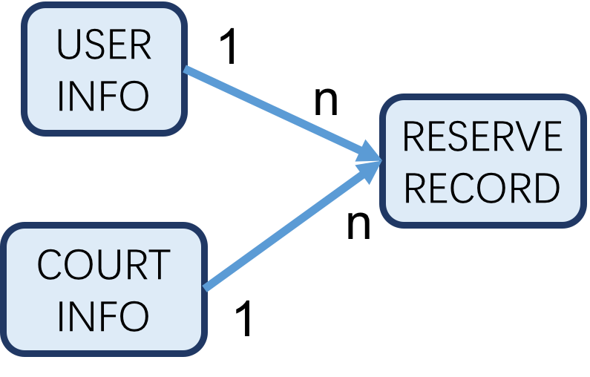

1. **数据库设计**

* **USER：**

**- user_id**

**- name**

**- username**

**- password**

**- phone**

* **COURT：**

**- court_id**

**- court_category**

**- stadium**

**- court_no**

* **RESERVE：**

**- reserve_id**

**- court_id**

**- start_date**

**- start_hour**

**- user_id**

**- status (1: success, 2: cancel, 3: fail)**

1. **用户注册：**

**register (username, password, name, telephone)**

**return True/False**

1. **用户登录：**

**login (username, password)**

**return True/False**

1. **用户信息查看：**

**user_info (user_id)**

**return [USER]**

1. **用户信息修改：**

**modify (username, new_password, new_phone)**

**return True/False**

1. **场馆名称id映射：**

**map_court_name_id ()**

**return [COURT]s**

1. **场地查询：**

**query_by_category (category)**

**return [COURT]s**

**query_by_time (start_time, hour)**

**return [COURT]s**

**query_by_category_and_time (category, start_time, hour)**

**return [COURT]s**

1. **预约场地：**

**reserve_court (court_id, start_time, hour)**

**return True/False**

1. **取消预约：**

**cancel reserve (reserve_id)**

**return True/False**

1. **用户查看所有预约记录：**

**reserve_info (user_id)**

**return [RESERVE]**